Strategic Plan Goal 5
REBUILDING THE DISTRICTS
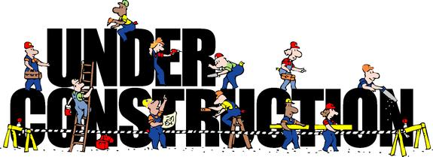
- At today’s GSA, we are introducing Goal 5 of area 50’s Strategic Plan – Rebuilding Our Districts.

- We will have presentations on this Goal today, including presentations from AA members who will share their experience, strength and hope – and success so far – in their efforts to rebuild their Districts.

- We will also have a presentation and a discussion regarding the idea of re-districting as part of the effort to Rebuild the District Structure.

- We are convinced that Rebuilding the Districts is CRITICAL to restoring Area 50 to health. And we are convinced that the Rebuilding will be successful ONLY if it is embraced by individual groups and members as part of OUR Responsibility under our Third Legacy of Service.

- GSRs and other attendees at today’s GSA have a critical role to play in this effort. We all have the responsibility to carry this message back to our Home Groups, and to the membership in Area 50. GSRs and others have a responsibility to exercise leadership on this issue by encouraging grass roots efforts in EVERY DISTRICT to bring the District structure back to life!

- Attached is a set of suggestions designed to guide the efforts to bring the Districts back to life. Ideas like these have been used to guide the rebuilding efforts you will hear described today.

- We urge you to carry these Guidelines back to the Groups and membership, and to help lead this Rebuilding effort forward.

- The complete set of Guidelines, with attachments, will be available on the Area 50 website (area50wny.org.) To save money and paper, we have not included the attachments in this handout.

For more information, please feel free to contact:
areachair@area50wny.org
cochair@area50wny.org

