***68th General Service Conference - Highlights***

**April 21-28, 2018 – Crowne Plaza Hotel, New York, NY**

**AAWS, Inc. (General Service Office)**

* Last year the General Service Office (GSO) responded to more than 90,000 emails and letters.
* The Contributions area received over 73,000 pieces of mail.
* The Corrections desk answered over 6,500 letters (17 letters per day, every day).
* Archives received over 1,300 requests for information and research.
* 8 million books, pamphlets & audio materials were shipped.
* 1,020 new AA groups in the U.S. and Canada were listed at GSO.
* The website (www.aa.org) received over 1,000 visits a day for “Need Help With A Drinking Problem” and 3,000 online requests per month for media and press information about AA.
* The website received over 12 million visits last year.

**Grapevine, Inc.**

* 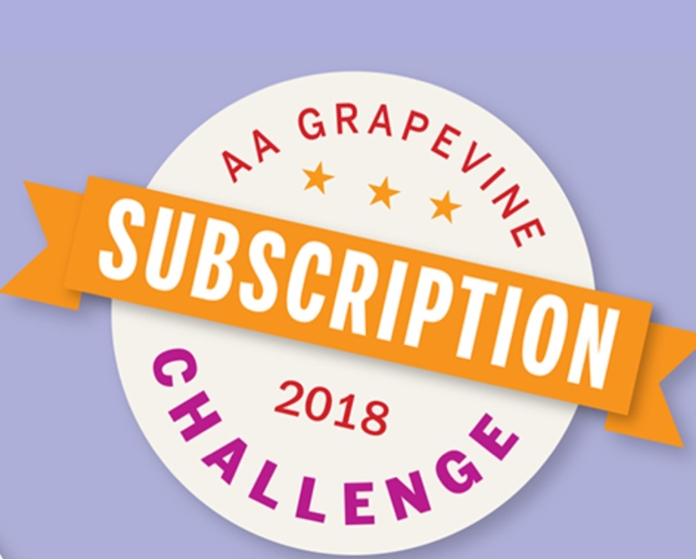Grapevine needs your help. The magazine has experienced a 33% decrease in subscriptions over the past 10 years. Please consider subscribing to the Grapevine at <http://www.aagrapevine.org>
* Increasing subscriptions is vital to preserving the voice of the Fellowship.
* Subscribing to online content is the key to building a sustainable Grapevine. Consider purchasing an eBook or an online subscription today.
* The Grapevine staff is doing is part to enhance the website experience, provide high-quality content, and get the message out about the important role Grapevine content plays in helping to carry the message.
* Last year, AA Grapevine, Inc. produced 12 issues of Grapevine; six issues of La Viña; two new books; a wall calendar; a pocket planner, and an app.



**Definition of Advisory Actions & Additional Committee Considerations**

* **Conference Advisory Actions** represent recommendations of the Conference committees, or floor actions that have been approved by the Conference body as a whole with substantial unanimity (2/3rds vote). Advises the Trustees how “we” want them to serve the Fellowship
* **Additional Committee Considerations** are items discussed, but no action taken or recommendation made, as well as committee recommendations which are not adopted.

**Key Conference Actions**

Key Advisory Actions:

* A.A. World Services, Inc. develop a company page on LinkedIn. (CPC Committee)
* The pamphlet “The God Word” (currently published by the General Service Board of A.A., Great Britain) be adopted by A.A. World Services, Inc. with minor editorial changes. (Literature)
* The Young People’s Video submission be approved. (Public Information)

Key Additional Committee Considerations:

* The committee thoughtfully reviewed a proposal to censure the General Service Board and after seeking extensive additional input from the general manager of G.S.O., the chair of the General Service Board, and additional General Service Board trustees, agreed to take no action. (Trustees Committee)
* The committee reviewed the 2018 Grapevine social media report regarding Instagram, Facebook, and Google for Nonprofits and suggests that A.A. Grapevine, Inc. continue to explore a social media strategy in their forthcoming strategic plan, taking into account issues regarding anonymity, security, affiliation, outside contributions, privacy and promotion. (Grapevine)
* The committee reviewed the 2017 trustees’ Public Information Committee Report on the use of Google AdWords and Google Grants to carry the A.A. message and requested that the trustees’ Committee continue to develop information on the use of Google AdWords and Google Grants including information on the cost of implementing a six month trial and the cost of a full year’s implementation and that a progress report be brought back to the 2019 Conference Committee on Public Information. (Public Information)

***Select* Conference Actions by Committee**

**Trustees**

Additional Committee Considerations:

* The committee thoughtfully reviewed a proposal to censure the General Service Board and after seeking extensive additional input from the general manager of G.S.O., the chair of the General Service Board, and additional General Service Board trustees, agreed to take no action. The committee recognized that the litigation regarding the Printer’s Copy Manuscript of *Alcoholics Anonymous* has caused many in the Fellowship to have strong feelings on all sides of this issue. The committee believes that the unity of Alcoholics Anonymous is the most important treasure we have as a Fellowship. The committee also recognizes that the General Service Board and the Alcoholics Anonymous World Services, Inc. Board have many legal responsibilities and must sometimes make use of the right of decision, but in the spirit of A.A. unity, the committee asks the General Service Board, A.A. World Services, Inc. and AA Grapevine, Inc. that:

**Trustees**

Additional Committee Considerations (Continued):

* + All major decisions made by A.A. World Services, Inc., AA Grapevine, Inc., the General Service Office or AA Grapevine management be promptly and fully reported to the General Service Board, as appropriate.
  + If the General Service Board, the A.A. World Services or AA Grapevine boards need to initiate a legal proceeding as a plaintiff, that whenever possible, they will consult the members of the General Service Conference before starting such a proceeding, being ever mindful of A.A. unity and A.A.’s financial prudence. However, the committee understands that sometimes this might not be possible.
* The committee recognizes that the General Service Board, A.A. World Services Inc., and AA Grapevine, Inc. could be brought into litigation by other parties and in no way wants to limit their actions required to protect these corporations.
* The committee reviewed a proposal to reorganize the A.A.W.S. and General Service Boards and took no action. The committee noted that although a reorganization was not considered necessary at this time, the committee requested that the trustees’ Committee on Nominating develop procedures for a partial or complete reorganization of the General Service Board, the A.A.W.S. or AA Grapevine boards and that a report be brought back to the 2019 Conference Committee on Trustees, including all possible options.

**Archives**

Advisory Action: It was recommended that the proposed new publication, Our Great Responsibility: A Selection of Bill W.’s General Service Conference Talks, 1951 – 1970 be approved with minor editorial changes.

**Cooperation with the Professional Community**

Advisory Actions: It was recommended that:

* A.A. World Services, Inc. develop a company page on LinkedIn
* Editorial changes be made to the following pamphlets: “A.A. as a Resource for the Health Care Professional”, “Members of the Clergy Ask About Alcoholics Anonymous”, and “If You Are a Professional…”

**Corrections**

Additional Committee Considerations:

* The committee discussed the request to create a pamphlet for inmates who will be released after long-term incarceration and took no action, but suggested that corrections service material be revised for this purpose.
* The committee suggested that the trustees’ Committee on Corrections create a letter to corrections professionals to raise awareness about prerelease and Bridging the Gap volunteers.
* The committee noted that many correctional facilities have increased their security restrictions for paper materials and suggests the trustees’ Committee on Corrections continue to work with the Publishing Department to insure access to A.A. materials for incarcerated alcoholics.

**Finance**

Advisory Action: It was recommended that:

* The Conference-approved maximum annual contribution from an individual A.A. member to

the General Service Board be increased from $3,000 to $5,000. *Note that the Conference-approved level of $5,000 for individual bequests was not changed.*

**Finance** (Continued)

Additional Committee Considerations:

* The committee discussed developing a method to standardize increases to the limits on individual contributions and bequests but took no action. A sense of the committee was that tying limits to a standardized adjustment such as the consumer price index may cause confusion and have unintended implementation costs.
* The committee had a discussion about AA Grapevine and suggested that the Grapevine have a greater online presence, a fact sheet on the topic of Grapevine be included in the Self-Support Packet, and that the General Service Board make available issues of Grapevine for distribution purposes through G.S.O. staff assignments.

**Grapevine**

Advisory Actions:

It was recommended that:

* AA Grapevine, Inc. allow sales of Grapevine and La Viña books, single-issue magazines (as available), and other products to non-AA entities, such as (but not limited to) hospitals, treatment centers and book stores. *Note: As a current practice, AA Grapevine, Inc. does not seek outside sales for magazine subscriptions.*
* AA Grapevine, Inc. continue to seek opportunities to expand bulk sales. *Note: AA Grapevine, Inc. currently offers volume discounts and will respond to requests, rather than solicit sales from outside entities.*
* AA Grapevine, Inc. provide notification to A.A. World Services’ list of non-A.A. entities to let them know that they can now purchase AA Grapevine and La Viña books, single-issue magazines (as available) and other products.
* La Viña be published at its current frequency of six times per year as a service to the Fellowship, with perfect binding, at 68 pages, and in full color.
* The revised pamphlet “AA Grapevine and La Viña: Our Meetings in Print” be approved and the title changed to “AA Grapevine and La Viña: Our Meetings in Print and Other Media.

Additional Committee Considerations:

* The committee reviewed the 2018 Grapevine social media report regarding Instagram, Facebook, and Google for Nonprofits and suggests that A.A. Grapevine, Inc. continue to explore a social media strategy in their forthcoming strategic plan, taking into account issues regarding anonymity, security, affiliation, outside contributions, privacy and promotion.
* The committee discussed ways groups can be kept informed about Grapevine and La Viña and suggested that all current and past delegates consider it a part of their responsibility to inform the Fellowship about Grapevine and La Viña as tools of sobriety, either through their own efforts or by recruiting others through email and area websites.

**Literature**

Advisory Actions: It was recommended that the following pamphlets be approved:

* “Experience, Strength, and Hope: Women in AA”
* “Experience, Strength, and Hope: LGBTQ Alcoholics in A.A.”
* “Inside AA: Understanding the Fellowship and its Services”
* “Experience, Strength and Hope: A.A. for Alcoholics with Mental Health Issues – and their sponsors”

It was recommended that:

* The title of the pamphlet “G.S.R. General Service Representative: May Be the Most Important Job in A.A.” be changed to “G.S.R. General Service Representative: Your Group’s Link to A.A. as a Whole.”
* Text (originally included in the 1998 edition of Living Sober) be added to Living Sober following the section titled “Note to Medical Professionals”.
* The trustees’ Literature Committee undertake a comprehensive update to the video “Your General Service Office, the Grapevine and the General Service Structure” to reflect a contemporary presentation of the General Service and AA Grapevine offices as well as a current portrayal of the General Service Structure and bring back a progress report or draft updated video to the 2019 Conference Committee on Literature.
* The pamphlet “The God Word” (currently published by the General Service Board of A.A., Great Britain) be adopted by A.A. World Services, Inc. with minor editorial changes.
* The trustees’ Literature Committee develop a pamphlet based on A.A.’s Three Legacies, with emphasis on the history of the Three Legacies, how they work together and including personal stories of members’ experiences with the Three Legacies and bring back a progress report or draft pamphlet to the 2019 Conference Committee on Literature.
* The trustees’ Literature Committee develop a pamphlet for Spanish-speaking women alcoholics by gathering sharing from Spanish-speaking women in A.A. and bring back a progress report or draft pamphlet to the 2019 Conference Committee on Literature.

Notable item recommended by the committee, but failed to pass the Conference:

* The committee recommended adding an appendix to the Big Book reflecting recognition received from the Library of Congress.
* The committee recommended that the Trustee’s literature committee develop text for an endnote to be placed at the end of the chapter, “Working with Others” in the Big Book, which would reflect contemporary experience regarding twelve-step calls, working with new prospects…

Additional Committee Considerations:

* The committee considered a request to add the A.A. Preamble and Responsibility Statement to the book Alcoholics Anonymous and took no action. The committee noted that the A.A. Preamble and Responsibility Statement are adequately noted in other A.A. literature.
* The committee considered a request to add an endnote to Bill W.’s story in the book Alcoholics Anonymous acknowledging co-founder, Bob S., and took no action. The committee noted that acknowledgement of Bob S. (“Dr. Bob”) as cofounder is currently mentioned in two separate places in the book Alcoholics Anonymous.
* The committee considered a request for the development of a new pamphlet for atheist and agnostic alcoholics and took no action. The committee agreed the recommendation that A.A.W.S. adopt/adapt the pamphlet “The God Word” responded to the need expressed by atheist and agnostic members of A.A.

**Policy/Admissions**

Additional Committee Consideration:

* The committee reviewed the trustees’ General Service Conference Committee’s Report on Equitable Distribution of the Workload of Conference Committees. The committee encourages the trustees’ Committee on the General Service Conference to continue reviewing options in order to create a workable plan for equitable distribution of the workload of Conference committees by combining and/or creating committees. The committee looks forward to a plan or progress report on this important process for review by the 2019 Conference Committee on Policy/Admissions.

**Public Information**

Advisory Actions: It was recommended that:

* The video PSA “Changes” be approved with a minor revision.
* The Young People’s Video submission be approved.
* The pamphlet “Understanding Anonymity,” with expanded content on Traditions Eleven and Twelve, be approved.
* The trustees’ Committee on Public Information develop language reflecting that A.A.’s anonymity Traditions are not a cloak protecting criminal or inappropriate behavior and that calling the proper authorities does not go against any A.A. Traditions. A progress report or draft language is requested to be brought back to the 2019 Conference Committee on Public Information.
* The updated pamphlet “A Brief Guide to Alcoholics Anonymous” be approved.

Additional Committee Considerations:

* The committee reviewed the 2017 trustees’ Public Information Committee Report on the use of Google AdWords and Google Grants to carry the A.A. message and requested that the trustees’ Committee on Public Information continue to develop information on the use of Google AdWords and Google Grants including information on the cost of implementing a six month trial and the cost of a full year’s implementation and that a progress report be brought back to the 2019 Conference Committee on Public Information.

**Treatment and Accessibilities**

Advisory Actions: It was recommended that:

* The title of the pamphlet “Accessibility for All Alcoholics” be changed to “Access to A.A.: Members Share on Overcoming Barriers.”
* The proposed changes by the trustees’ Committee on Cooperation with the Professional Community/Treatment and Accessibilities to the pamphlet “Accessibility for All Alcoholics” be approved with additional revisions.
* The Scope of the Conference Committee on Treatment and Accessibilities be expanded.

Additional Committee Considerations:

* The committee reviewed the report “Cooperation with Armed Services Exploration Strategies” from the trustees’ Committee on Cooperation with the Professional Community/Treatment and Accessibilities and made a number of suggestions.
* The committee reviewed the summary of sharing from A.A. members who are Deaf and Hard-of-Hearing from the trustees’ committee on Cooperation with the Professional Community /Treatment and Accessibilities and made a number of suggestions.

**Financial Highlights**

* The General Service Office profit was $1.7M, driven by increases in contributions and higher than expected gross profit from publishing activities.
* Seventh Tradition contributions increased 6% from 2017 to a record $8.4M in 2017, which brings us closer to fully supporting the cost of services G.S.O provides to the Fellowship!
* Cost of services that G.S.O. provided to the Fellowship were $10.2M. This was about $1.8M less than the $8.4M received in contributions. Contributions provided 82.3% of the total cost of services to the Fellowship.
* Net income from G.S.O. literature sales was $3.6M, which covered the shortfall between contributions and the cost of services, while also resulting in a $1.7M profit for G.S.O.
* Grapevine’s profit was $126,128, in spite of 5% decline in subscriptions.
* General Fund support of the La Viña service activity was $126,440.

**Did you know that AA Groups and Individual Members Can Now Make Contributions Online? Just go to** [**www.aa.org**](http://www.aa.org) **and click on the “MAKE A CONTRIBUTION” button.**

*Respectfully submitted by Chuck B.*

*Panel 68, Area 50 (WNY) Delegate at* [*delegate@area50wny.org*](mailto:delegate@area50wny.org)