AA Area 50
2022
Inventory Questions

Answers and Comments can be sent to:
Email to: a50ttloinventory@gmail.com
Snail Mail to:
Inventory Survey
40 Prout Rd,
Freeport, ME 04032

or
Hand it to your GSR or DCM

Entire Survey Online: Inventory – Area 50 WNY

Deadline for Submission - December 10th, 2022

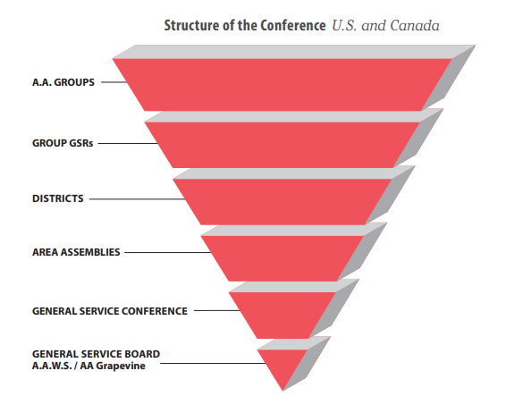
Goal 1: Improve Communications with the Groups and Members
Communication within the General Service structure is reflected in the following upside-down triangle. A GSR (General Service Representative) is a Homegroups' primary link in the General Service structure. Common forms of communication used by Area 50 include (but are not limited to) Area 50/local District websites, Area 50 email, announcements, Area 50/local District monthly meetings, and social media sites.

- How is Area 50 communicating with groups and members?

- How is Area reaching out to the in-person groups?

- How is Area reaching out to the virtual groups?

- What is the evidence this has been effective?

- How are Area officers discovering which groups have GSRs? Do the Area officers visit homegroups/districts/

- Do the GSRs know what their job entails (description/ time & travel requirements)?

- If you were Rule maker for the day, what reasonable solution would you insist upon to make certain communication is actively occurring between Area and the groups and individual members?

Goal 2: Understanding the Role of Each AA Constituency in General Service
Each Constituency (Area Officers, Chairpersons, DCMs, GSRs, Groups) and its corresponding description and duties are clearly outlined in the Area 50 Handbook. The Handbook is accessible on the area 50 website and available in hard copy form.
Area 50 Handbook Section II, III and IV Handbook – Area 50 WNY

- How does a member get information about their A.A. position? Who is responsible for guiding them in the direction of being informed?

- How frequently do Districts/Area offer workshops/days of learning/education events to A.A. members?

- When and how does an invite go out to all known members about workshops/days of learning/education events? How is an invite to an event spread to inactive groups?

- What can make workshops/days of learning/education events more interesting?

- Are the positions, which are open, announced at meetings or other events? Do you announce them if no one in the group does?

- If you were Rule maker for the day, what reasonable solution would you insist upon to make certain that everyone who takes a position in A.A. understands their role?

Goal 3 – Improving the Work and Visibility of the Service Committees
Area 50 has 8 Service Committee Chairs: Accessibilities, Archives, Cooperation with Professionals, Correction Facilities, Finance, Literature/AA Grapevine/La Vina, Public Information, Treatment Facilities, GSA Education and GSR Orientation. More specific definitions on Area 50 Handbook. Individual Service guidelines are on AA.org
Area 50 Handbook, November 2020, page 8 Handbook – Area 50 WNY

- How is Area 50 utilizing their past delegates?

- How does Area exemplify unity within the districts/groups/members?

- How does one get involved with a Service Committee? Is it clear to the individual member where to reach out if they are interested in being a part of a Service Committee?

- What action(s) has Area taken to ensure service committees/positions are available to those searching to be part of one of them?

- Where do you as a group or service committee member practice improving the work and visibility of the various service committees and open positions?

- If you were Rule maker for the day, what reasonable solution would you insist upon to make certain Service Committees are improving work and visible to those wanting to be involved?

Goal 4: Increase Cooperation and Coordination with the Intergroups
The Area and the Local Intergroups (Central Offices) are two separate but vital service structures who coexist in many areas in mutual cooperation and harmony.

Traditionally, Areas and Intergroup/Central Offices have performed different functions. Area 50 has Liaisons who help communicate and coordinate information between the Area and the Intergroup.

AA Guidelines on Central or Intergroup Offices at AA.Org
AA Service Manual 2018-2022 Downloads – Area 50 WNY
Area 50 Handbook 2020 Handbook – Area 50 WNY

- Who is responsible for education re: Area and Intergroups?

- Where do Intergroups fall in the Area 50 upside down triangle (Service Structure)?

- Where does Area and Intergroup duplicate their efforts?

- How do Area and Intergroups communicate events/open positions/information from the General Service Assembly and/or the General Service Office?

- What “services” can Area and Intergroups offer together that would amalgamate the two entities increasing cooperation and coordination with the Intergroups?

- If you were Rule maker for the day, what reasonable solution would you insist upon to ensure there is cooperation and coordination between Area and the Intergroups?

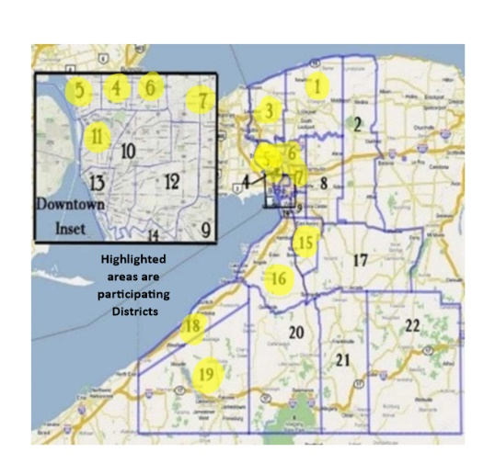
Goal 5: Revive and Revise the District Structure
REVIVE definition: Restore to life or consciousness: regain life, consciousness, or strength: give new strength or energy.
Districts are the vital link between the AA groups and AA as a whole. Districts work with the GSRs who work with the Homegroup, who communicate up and down the triangle. Most Districts conduct monthly meetings.
AREA 50 Handbook (2022) page 2

Highlighted Areas are participating in the Area

- How has Area assisted in district structuring or restructuring in the past?

- When districts have questions, are they answered in a reasonable time frame?

- What is the expectation for a district who is struggling and needs assistance? How do they ask for help? Is there a process? Is there a resource available?

- What effective ways are districts reaching out to their groups to share information about how district functions? How it stands financially? How can groups get involved? How can Area assist in this process?

- If you were Rule maker for the day, what reasonable solution would you insist upon to ensure a healthy, robust district?

Goal 6: Re-Imagine the Structure and Function of the Assemblies
Assembly meetings consider a variety of issues, from General Service Conference business to Area problems and solutions, while sharing sessions, public information programs, workshops, and video programs which keeps A.A. strong and participative in growing service.
Service Manual (2022) page S36 Downloads – Area 50 WNY

- What motivates DCMs/GSRs/members to attend the General Assemblies?

- How can the enthusiasm felt by some become infectious throughout Area 50?

- What does the Area do to build excitement about attending a General Assembly?

- Are there only a few who spread the word of the General Assembly? How do districts and groups know about Area agenda items? How do districts and groups find out about General Service Conference agenda items?

- What responsibility do the Area Officers take to educate the districts/groups/individual members? How could it be more effective?

- If you were Rule maker for the day, what reasonable solution would you insist upon to ensure an Area structure that would function at a higher level?

